# inBloom Dashboard Administration

inBloom Dashboards display student data for authorized users, such as educators and school, district, and state leaders. Once data is ingested into inBloom, it appears in one of two places:

• *Section Profiles* display a listing of each student in a section as well as relevant information about that student. The section profiles also allow users to easily sort and filter students based on list criteria.

• *Student Profiles* display more in-depth information about an individual student. Information includes enrollment history, academic transcript history, and parent contact information.

This page describes how you, as an administrator, can configure the inBloom Dashboard for the users within your tenancy.

## Configuring the inBloom Dashboard

Configuring the inBloom Dashboard takes just a few steps:

1. Determine your highest priority goals for using inBloom data. This helps determine your data ingestion plan.
2. Plan how you want the data to be displayed for your users. This can be accomplished by reviewing the options for profiles and lists later in this section.
3. Complete the configuration template document for the Dashboards. If you're unsure about any of the fields, please write questions directly in the template.
4. inBloom partners create the configuration code in JSON. This may take up to several weeks, depending on the complexity of the request.
5. When you receive the configuration code from your inBloom partner, an authorized contact in your district can upload the code to the Dashboard application.

## Configuring Section Profile Lists

The Section Profile provides a table of information about students in a class or section, resembling a teacher's gradebook. The first column is always the student's name, which a user can click to view that student's profile. The second column includes indicators for the student, such as whether the student is an English Language Learner (ELL) or has an Individual Development Plan (IDP). The remainder of the table can include any combination of columns.

Figure 1: Example Section Profile

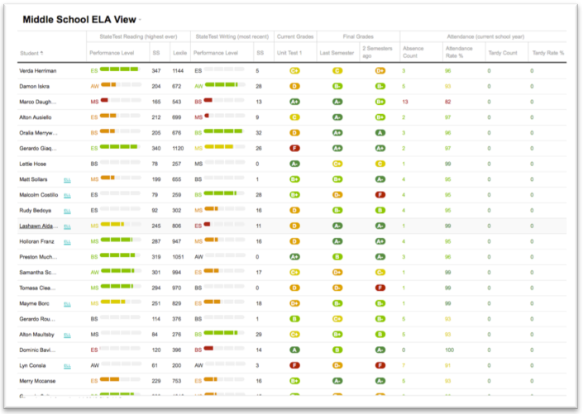

### Documenting your List Configurations

Use the following steps to set up your list configurations:

1. Open the List of Students Configuration Template spreadsheet.  Each tab in the file allows you to enter a different view, and each view has its own Microsoft Excel worksheet in the workbook document. The template has several blank worksheets, and you can duplicate additional tabs if needed.
2. Fill in the blue fields at the top of the worksheet. The fields are:
   * The View Name field is the title of the view. It appears as the title in the view dropdown on the Dashboard.
   * The Max Grade Range (inclusive) and Min Grade Range (inclusive) fields allow you to enter grade ranges for this view. Leave this blank to show all grade ranges.
   * The District field allows you to enter your school district name (for your reference).
3. Fill in the next block of blue text in the tab. The Name and Indicator columns are there by default and should not change.
   * A Column Category row precedes each group of similar-type columns.
   * The Column Type row is the specific column of information (for example, Most Recent Assessment Result).
   * Configuration Options, Line 1 and Configuration Options, Line 2 are options for the view. For specific information, please see the table below.
   * The Header Line options allow you to change the heading on that row of the table within the UI.
   * The Sample Text row allows you to enter example text for your users.

Table 1 List View Options

|  |  |  |
| --- | --- | --- |
| **Column Type** | **Description** | **Configuration Options** |
| Attendance | | |
| Attendance Rates | Displays the student's attendance rates. This can be a percentage of days in attendance compared to the total days, or it can be the percentage of days tardy compared to the total days. | * Select the rate type to display: attendance percentage or tardy percentage. * Select the timeframe: this school year, or only this semester or session. * (Optional) Indicate the color- coding cut points. |
| Attendance Event Counts | Shows a count of the total number of days a student is absent or tardy. | * Select the attendance count type to display: excused absences, unexcused absences, or all absences. * Select the timeframe: this school year, or only this semester (or session). * (Optional) Indicate the color- coding cut points. |
| Assessment | | |
| Most Recent Assessment in a Family | Displays the results of the most recent assessment within an assessment family for a student. | * Select an assessment family. * Choose an outcome to display: numeric score or performance level. * (Optional) Provide a scale score and cut points. * Choose to display the depth of assements within time: most recent, 2nd most recent, etc. |
| Highest Ever | Displays the highest results for an assessment within a given assessment family for a student. | * Select an assessment family. * Choose an outcome to display: numeric score or performance level. * (Optional) Provide a scale score and cut points. * Choose to display the depth of assements within time: most recent, 2nd most recent, etc. |
| Grades | | |
| Most Recent Transcript Grade for a Subject Area | Shows the most recent transcript scores for a completed course in the subject area you are viewing. | * Choose to display the most recent, 2nd most recent, etc. * The grade book entires are determined by the selected course. This is not configurable. |
| Most Recent Gracde Book Entry | Shows the most recent grade book entry for the course you are viewing. | * Choose to display the most recent, 2nd most recent, etc. * The grade book entires are determined by the selected course. This is not configurable. |

## Configuring Student Profiles

Student profiles display in-depth information on an individual student. Profiles consist of a page with one or more tabs. The first panel of each tab (page) is always the core student information and is not configurable. The remainder of the page can contain any combination of panels.

Figure 2 Example Student Profile

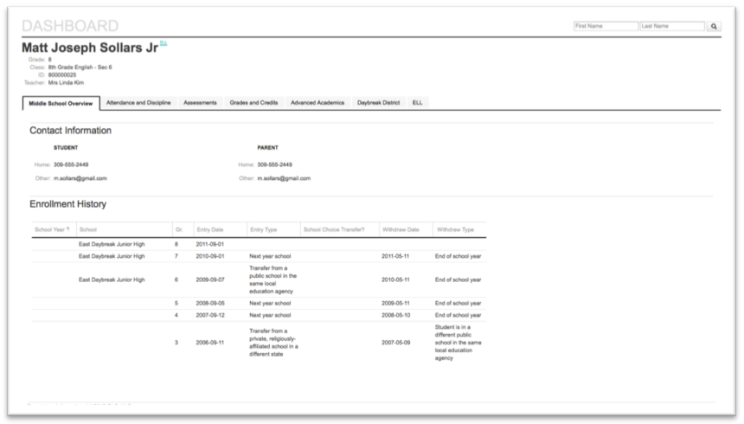

### Documenting your Student Profile Configuration

Before your inBloom partner contact can create the JSON for your Dashboard configuration, you must complete the spreadsheet using the following steps:

1. Open the Student Profile Template spreadsheet. Each tab in the bottom portion of the worksheet’s window represents a different page on the student profile. If you need additional tabs to create additional pages, simply duplicate an existing tab.
2. Fill in the blue fields at the top of the worksheet:
   * The Page Name field displays the name of the page.
   * The Grade Levels field allows you to enter the grade levels that you want to display.
   * The District field allows you to enter your school district name for reference.
3. Fill in the fields for the panels that should be included on the page:

* The Panel Title appears above the appropriate panel.
* The Panel Type field describes the type of panel that must be included. Select one of the panel types below.
* The Panel Configuration field allows you to modify the panel’s properties. **Note:** Several panels are not configurable.

|  |  |  |
| --- | --- | --- |
| **Panel** | **Description** | **Configuration Options** |
| Core Student Information | Displays the student's name, nickname, State ID, Grade Level, and (in some schools) the student's homeroom and homeroom teacher. | This always appears on student profiles and is not configurable. |
| Current Contact Information | Displays the names, addresses, phone numbers, and email addresses for a student. | This is not configurable. |
| Enrollment History | Displays all the schools in which a student has been enrolled. This includes entrance and exit reasons, dates, and grades. | This is not configurable. |
| Assessment History | Displays all of the information for a student assessments within a given assessment family. | This can be configured to display any node on the assessment family tree. You can also configure this to display all the results for child nodes. |
| Transcript History | Displays the complete student's transcript. This includes all available grade data for each year and semester. The GPA for each semester is available in the summary. | This is not configurable. |
| Attendance History | Displays a calendar that shows the days a student was absent (excused or unexcused) or tardy for the whole school day. | The default number of years included is three (3) years. |

## Uploading Configurations for Your District

Once you've completed the spreadsheet, please send it to the inBloom partner organization contact for your district. Your partner will generate a piece of configuration code in JSON format. When this is complete, you will receive the code in an email. You can then upload this code to your district's Dashboard using the steps that follow.

### Caution

You must upload the JSON code as you receive it from the inBloom partner. Do not modify the code before uploading it. Any changes, even seemingly minor ones, present a risk to your and other district’s Dashboards when you upload the code. If you notice a mistake in the JSON you receive, work with the inBloom partner to make corrections rather than attempting them yourself.

To upload the JSON configuration code:

1. Log in to your inBloom Portal.
2. Select the SEA or LEA realm for your site.
3. Click Admin.
4. Click inBloom Dashboards under the Application Configuration heading.
5. Paste the JSON configuration code that was emailed to you. Click Save Config.

### Important Considerations for inBloom Dashboard Configuration

* Uploading a new configuration overwrites all previous configurations.
* The configuration changes take effect the next time that a user logs in to the application.
* Users who are using the inBloom Dashboard while you upload any configuration changes may encounter errors. These errors should clear once they login again.
* Make sure that configurations are secure, including securing documents and emails, so that only authorized people in your district can see them.

# Modifying Your District’s Dashboard

The inBloom Dashboard provides users access to data for schools, courses, sections, teachers, and students in a navigable and easy-to-read format. Users who can use the inBloom Dashboard can access it from the home page of their inBloom Portal.

After the initial setup, an LEA administrator can modify the layout for their Dashboard using the inBloom Dashboard builder application as described in this document.

## Terms

Before you continue, please understand the following terms:

* **Profile** – A profile is a collection of logically related data organized by scope. The default profiles on the Dashboard are the Dashboard Profile, School Profile, Student Profile, State Education Organization Profile, Education Organization Profile, Teacher Profile, and Section Profile.
* **Page** – Profiles are made up of one or more pages. Pages help organize the data panels and appear as tabs on a profile.
* **Panel** - Contained within each page are one or more panels that display data for the profile. Panels can currently be added or removed from a pre-defined library, broken down by profile. For example, a teacher panel can be added to the education organization's profile.
* **Widget** – A reusable user interface element with common population interface, e.g. drop-down, grid, tab menu.
* **Layout** - A configurable user interface component that has a notion of a header, navigation, and grouped content (panels).

For example, a school profile could include pages for teachers and students. Within the students page, you may have panels for grades, attendance, or just general information.

## Modifying a Profile

To modify a profile:

1. Log into inBloom.
2. Click on the inBloom Dashboard.
3. In the address bar, add */builder/index.html* to the end of the URL.
4. Click the Profiles menu. The menu expands to display the list of available profiles.
5. Click the name of the profile that you want to edit. The profile page appears.

Figure 3 An Example School Profile

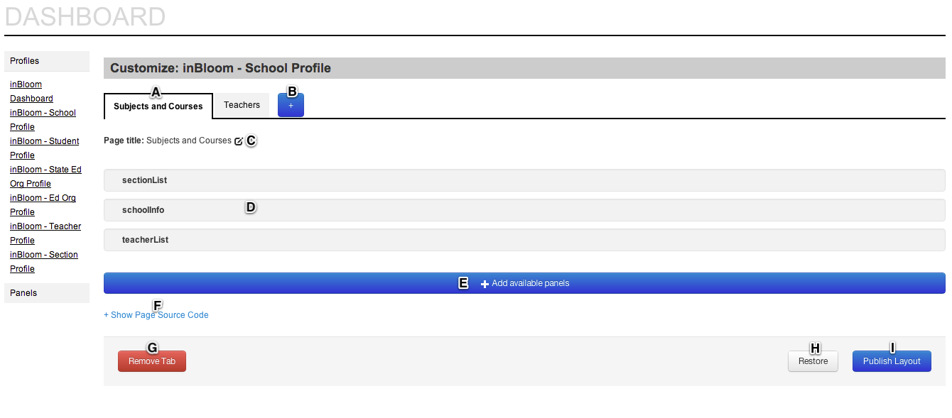

* A – The tabs display the individual pages/tabs that will display for the profile. In the example school profile, the school profile displays tabs for Subjects and Courses and Teachers. Click a tab to view that tab's configuration.
* B - Click the Add Page button to add a new page to the profile. Once you have added the page, you can add panels that are available for the profile.
* C – The page title describes the tab as it will appear on the Dashboard profile. Click the Edit button to change the text for the page/tab title.
* D – The active panels are displayed and can be rearranged using a drag and drop feature. Hover over the panel to activate the ability to remove a panel or to change the order of panels.
* E – Click the Add available panels button to add new panels to the page. When you click the button, a dialog appears that allows you to select from panels available for the profile.
* F – Click Show Page Source Code to display the JSON code for a profile page. This allows you to easily share configurations with other administrators, as well as make changes to your Dashboard pages in a way not currently supported by the builder interface.
* G – Click Remove Tab to remove the page/tab from the profile.
* H – Click Restore to reset the profile to it’s most recently saved state.
* I - Click Publish Layout to update your district’s Dashboard with your changes. **Note**: You are prompted to confirm the changes before the profile is updated for your education organizations.

## Panels

The inBloom Dashboard comes with a default library of data panels. Each panel can be added to or removed from its associated profile. The inBloom Dashboard does not currently support the ability to modify the panel library.

Figure 4 Available Panels for a School Profile

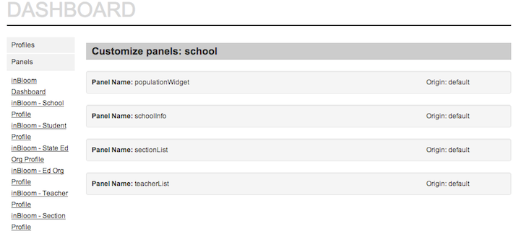

## Widgets

Table 2 Available Widgets

|  |  |
| --- | --- |
| TearDrop, Grade |  |
| FuelGaugeWithScore, FuelGauge |  |
| CutPoint, CutPointReverse |  |
| Lozenge |  |
| restLink |  |

## JSON Configuration

|  |  |  |
| --- | --- | --- |
| **Key** | **Sample Value(s)** | **Description** |
| config.id | listOfStudents | The unique id of the configuration |
| data.entity | "listOfStudents", "teacherInfo" | The entities from which to pull information |
| data.type | “FIELD”, “PANEL”, “TAB” |  |
| params.link | “student”, “section”, “teacher” |  |
| params.target | “_self” |  |
| params.sortField | “assessments.StateTest Reading.Scale score” | The field which will be the default sort field |
| items | See sample configurations | Array of grid entries |
| items.name | “Middle School View” | The name of the grid entry, used in drop down menu selection |
| items.width | 150 | Width, in pixels, of the grid column |
| items.field | “name.firstName” | Data point to be pulled from data.entity  For example, the name.firstName is a field to be pulled from a student entity |
| items.style | “ui-ellipsis”, “color-widget-darkgreen” | The CSS class that defines the style of the element |
| items.formatter | “restLink”, “Lozenge”, “CutPointReverse” | The widget formatter for data point |
| items.sorter | "Enum", "ProxyInt", "LetterGrade", "LettersAndNumbers" | Defines a custom sort method for data |
| items.params | cutPoints:{ 89:{ style:'color-widget-red' }, 94:{ style:'color-widget-yellow' }, 98:{ style:'color-widget-green' }, 100:{ style:'color-widget-darkgreen' }} | Parameters passed – for defining custom cutpoints for grade levels, attendance counts, etc |
| items.condition | { field:”gradeLevel”, value:[“First Grade”, “Second Grade”]} | Place constraints on which data to be presented (e.g., only First and Second graders) |

## Sample JSON Configurations

**Simple List of Students**

*{*

*id : "listOfStudents",*

*type : "PANEL",*

*data :{*

*lazy: true,*

*entity: "listOfStudents",*

*cacheKey: "listOfStudents"*

*},*

*params: {*

*layout: ["section"]*

*},*

*root: 'students',*

*items : [*

*{name: "Default View",*

*items: [*

*{name: "Student", width: 150, field: "name.fullName", formatter:restLink, style:'ui-ellipsis', params: {link:'student', target:"_self"}},*

*{name: "", width: 60, field: "programParticipation", formatter: Lozenge},*

*{name: "Grade", field: "score.grade", width:50, formatter: TearDrop},*

*{name: "Absence Count", field: "attendances.absenceCount", width:100, sorter: 'int', formatter: CutPointReverse, params:{cutPoints:{0:{style:'color-widget-darkgreen'}, 1:{style:'color-widget-green'}, 6:{style: 'color-widget-yellow'}, 11:{style:'color-widget-red'}}}},*

*{name: "Tardy Count", field: "attendances.tardyCount", width:100, sorter: 'int', formatter: CutPointReverse, params:{cutPoints:{0:{style:'color-widget-darkgreen'}, 1:{style: 'color-widget-green'}, 6:{style:'color-widget-yellow'}, 11:{style:'color-widget-red'}}}}*

*]*

*}*

*] }*

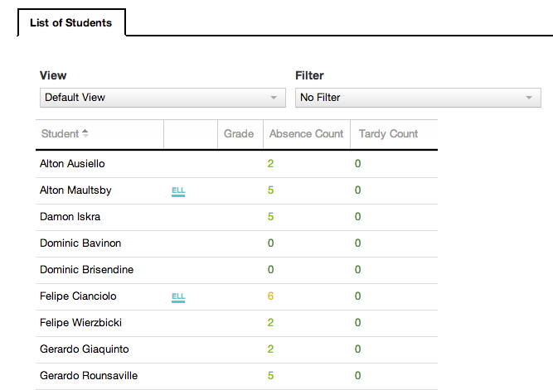

**Enrollment History Panel**

*{*

*id : "enrollmentHist",*

*type : "PANEL",*

*name : "Enrollment History",*

*data :{*

*entity: "student",*

*cacheKey: "student"*

*},*

*items : [*

*{id: "col1", name: "School Year", type:"FIELD", datatype: "string", field: "studentSchool.schoolYear", width: 100},*

*{id: "col2", name: "School", type:"FIELD", datatype: "string", field: "studentSchool.nameOfInstitution", width: 220},*

*{id: "col3", name: "Gr.", type:"FIELD", datatype: "string", field: "studentSchool.entryGradeLevel", width: 80},*

*{id: "col4", name: "Entry Date", type:"FIELD", datatype: "string", field: "studentSchool.entryDate", width: 120},*

*{id: "col5", name: "School Choice Transfer?", type:"FIELD", datatype: "string", field: "studentSchool.transfer", width: 180},*

*{id: "col6", name: "Withdraw Date", type:"FIELD", datatype: "string", field: "studentSchool.exitWithdrawDate", width: 120},*

*{id: "col7", name: "Withdraw Type", type:"FIELD", datatype: "string", field: "studentSchool.exitWithdrawType", width: 120}*

*]*

*}*

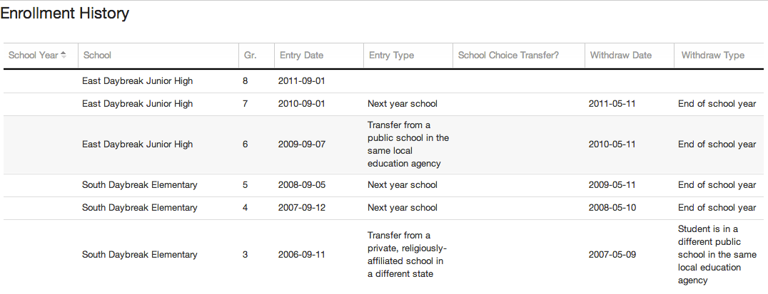

**Enhanced LoS (Text box – this JSON document is large)**

{config:{"listOfStudents":{id:"listOfStudents",type:"PANEL",data:{lazy:true,entity:"listOfStudents",cacheKey:"listOfStudents",params:{assessmentFilter:{"StateTest Reading":"HIGHEST_EVER","StateTest Writing":"MOST_RECENT_WINDOW","READ 2.0":"MOST_RECENT_WINDOW","TRC":"MOST_RECENT_WINDOW","SAT Reading":"HIGHEST_EVER","SAT Writing":"HIGHEST_EVER","AP Language":"HIGHEST_EVER","AP Literature":"HIGHEST_EVER"}}},root:'students',items:[{name:"Middle School ELA View",condition:{field:"gradeLevel",value:["Third grade","Fourth grade","Fifth grade","Sixth grade","Seventh grade","Eighth grade"]},items:[{name:"Student",width:150,field:"name.fullName",style:"ui-ellipsis",formatter:'restLink',params:{link:'student',target:"_self"}},{name:"",width:60,field:"programParticipation",formatter:'Lozenge'},{name:"StateTest Reading (highest ever)",items:[{name:"Performance Level",field:"assessments.StateTest Reading.perfLevel",width:150,sorter:'ProxyInt',formatter:'FuelGaugeWithScore',params:{sortField:'assessments.StateTestReading.Scalescore',name:'StateTestReading',valueField:'Scalescore',fieldName:"StateTestReading",cutPoints:{5:{style:'color-widget-darkgreen'},4:{style:'color-widget-green'},3:{style:'color-widget-yellow'},2:{style:'color-widget-orange'},1:{style:'color-widget-red'}}}},{name:"SS",field:"assessments.StateTest Reading.Scale score",width:45,sorter:'int'},{name:"Lexile",field:"assessments.StateTest Reading.Other",width:45,sorter:'int'}]},{name:"StateTest Writing (most recent)",items:[{name:"Performance Level",field:"assessments.StateTest Writing.perfLevel",width:150,sorter:'ProxyInt',formatter:'FuelGaugeWithScore',params:{sortField:'assessments.StateTestWriting.Scalescore',name:'StateTestWriting',valueField:'Scalescore',fieldName:"StateTestWriting",cutPoints:{5:{style:'color-widget-darkgreen'},4:{style:'color-widget-green'},3:{style:'color-widget-yellow'},2:{style:'color-widget-orange'},1:{style:'color-widget-red'}}}},{name:"SS",field:"assessments.StateTest Writing.Scale score",width:45,sorter:'int'}]},{name:"Current Grades",items:[{name:"Unit Test 1",field:"currentSession-0",width:100,sorter:'LettersAndNumbers',formatter:'Grade'}]},{name:"Final Grades",items:[{name:"Last Semester",field:"previousSemester",width:100,sorter:'LetterGrade',formatter:'TearDrop'},{name:"2 Semesters ago",field:"twoSemestersAgo",width:90,sorter:'LetterGrade',formatter:'TearDrop'}]},{name:"Attendance (current school year)",items:[{name:"Absence Count",field:"attendances.absenceCount",width:60,sorter:'int',formatter:'CutPointReverse',params:{cutPoints:{0:{style:'color-widget-darkgreen'},1:{style:'color-widget-green'},6:{style:'color-widget-yellow'},11:{style:'color-widget-red'}}}},{name:"Attendance Rate %",field:"attendances.attendanceRate",width:75,sorter:'int',formatter:'CutPoint',params:{cutPoints:{89:{style:'color-widget-red'},94:{style:'color-widget-yellow'},98:{style:'color-widget-green'},100:{style:'color-widget-darkgreen'}}}},{name:"Tardy Count",field:"attendances.tardyCount",width:50,sorter:'int',formatter:'CutPointReverse',params:{cutPoints:{0:{style:'color-widget-darkgreen'},1:{style:'color-widget-green'},6:{style:'color-widget-yellow'},11:{style:'color-widget-red'}}}},{name:"Tardy Rate %",field:"attendances.tardyRate",width:61,sorter:'int',formatter:'CutPointReverse',params:{cutPoints:{0:{style:'color-widget-darkgreen'},1:{style:'color-widget-green'},6:{style:'color-widget-yellow'},11:{style:'color-widget-red'}}}}]}]},{name:"Early Literacy View",condition:{field:"gradeLevel",value:["Kindergarten","First grade","Second grade","Third grade"]},items:[{name:"Student",field:"name.fullName",width:150,formatter:'restLink',style:"ui-ellipsis",params:{link:'student',target:"_self"}},{name:"",width:60,field:"programParticipation",formatter:'Lozenge'},{name:"READ 2.0",items:[{name:"Performance Level",field:"assessments.READ 2_0.perfLevel",width:100}]},{name:"Reading",items:[{name:"RL",field:"assessments.TRC.readingLevel",width:100},{name:"Prof. Level",field:"assessments.TRC.profLevel",width:100}]},{name:"Attendance",items:[{name:"Absence Count",field:"attendances.absenceCount",sorter:'int',width:60,formatter:'CutPointReverse',params:{cutPoints:{0:{style:'color-widget-darkgreen'},1:{style:'color-widget-green'},6:{style:'color-widget-yellow'},11:{style:'color-widget-red'}}}},{name:"Tardy Count",field:"attendances.tardyCount",sorter:'int',width:50,formatter:'CutPointReverse',params:{cutPoints:{0:{style:'color-widget-darkgreen'},1:{style:'color-widget-green'},6:{style:'color-widget-yellow'},11:{style:'color-widget-red'}}}}]}]},{name:"College Ready ELA View",condition:{field:"gradeLevel",value:["Ninth grade","Tenth grade","Eleventh grade","Twelfth grade"]},items:[{name:"Student",field:"name.fullName",width:150,formatter:'restLink',style:"ui-ellipsis",params:{link:'student',target:"_self"}},{name:"",width:60,field:"programParticipation",formatter:'Lozenge'},{name:"Reading Test Scores (Highest)",items:[{name:"SAT",field:"assessments.SAT Reading.x",width:100,sorter:'int'},{name:"%ile",field:"assessments.SAT Reading.percentile",width:100,sorter:'int'}]},{name:"Writing Test Scores (Highest)",items:[{name:"SAT",field:"assessments.SAT Writing.x",width:100,sorter:'int'},{name:"%ile",field:"assessments.SAT Writing.percentile",width:100,sorter:'int'}]},{name:"AP Eng. Exam Scores (Highest)",items:[{name:"Lang.",field:"assessments.AP Language.x",width:100},{name:"Lit.",field:"assessments.AP Literature.x",width:100}]},{name:"Final Grades",items:[{name:"Last Semester",field:"previousSemester",width:100,sorter:'LetterGrade',formatter:'TearDrop'},{name:"2 Semesters ago",field:"twoSemestersAgo",width:90,sorter:'LetterGrade',formatter:'TearDrop'}]},{name:"Attendance",items:[{name:"Absence Count",field:"attendances.absenceCount",width:60,sorter:'int',formatter:'CutPointReverse',params:{cutPoints:{0:{style:'color-widget-darkgreen'},1:{style:'color-widget-green'},6:{style:'color-widget-yellow'},11:{style:'color-widget-red'}}}},{name:"Attendance Rate %",field:"attendances.attendanceRate",width:75,sorter:'int',formatter:'CutPoint',params:{cutPoints:{89:{style:'color-widget-red'},94:{style:'color-widget-yellow'},98:{style:'color-widget-green'},100:{style:'color-widget-darkgreen'}}}},{name:"Tardy Count",field:"attendances.tardyCount",width:50,sorter:'int',formatter:'CutPointReverse',params:{cutPoints:{0:{style:'color-widget-darkgreen'},1:{style:'color-widget-green'},6:{style:'color-widget-yellow'},11:{style:'color-widget-red'}}}},{name:"Tardy Rate %",field:"attendances.tardyRate",width:60,sorter:'int',formatter:'CutPointReverse',params:{cutPoints:{0:{style:'color-widget-darkgreen'},1:{style:'color-widget-green'},6:{style:'color-widget-yellow'},11:{style:'color-widget-red'}}}}]}]}]},"student":{id:"student",name:"inBloom - Student Profile",type:"LAYOUT",data:{entity:"student",cacheKey:"student"},items:[{id:"csi",name:"Student Info",type:"PANEL"},{id:"tab7",name:"Elementary School Overview",type:"TAB",condition:{field:"gradeLevel",value:["Infant/toddler","Early Education","Preschool/Prekindergarten","Transitional Kindergarten","Kindergarten","First Grade","Second Grade","Third Grade","Other","Ungraded","Not Available"]},items:[{id:"contactInfo",type:"PANEL"},{id:"enrollmentHist",name:"Student Enrollment Panel",type:"GRID"}]},{id:"tab8",name:"Middle School Overview",type:"TAB",condition:{field:"gradeLevel",value:["Fourth Grade","Fifth Grade","Sixth Grade","Seventh Grade","Eighth grade","Other","Ungraded","Not Available"]},items:[{id:"contactInfo",type:"PANEL"},{id:"enrollmentHist",name:"Student Enrollment Panel",type:"GRID"}]},{id:"tab9",name:"High School Overview",type:"TAB",condition:{field:"gradeLevel",value:["Ninth grade","Tenth grade","Eleventh grade","Twelfth grade","Adult Education","Grade 13","Postsecondary","Other","Ungraded","Not Available"]},items:[{id:"contactInfo",type:"PANEL"},{id:"enrollmentHist",name:"Student Enrollment Panel",type:"GRID"}]},{id:"tab2",name:"Attendance and Discipline",type:"TAB",items:[{id:"attendanceHist",type:"REPEAT_HEADER_GRID"},{id:"studentAttendanceCalendar",type:"PANEL"}]},{id:"tabE",name:"Assessments",type:"TAB",items:[{id:"assessmentHistREAD2",type:"GRID"}],condition:{field:"gradeLevel",value:["Infant/toddler","Early Education","Preschool/Prekindergarten","Transitional Kindergarten","Kindergarten","First Grade","Second Grade","Third Grade","Other","Ungraded","Not Available"]}},{id:"tabM",name:"Assessments",type:"TAB",items:[{id:"assessmentHistStateTestR",type:"GRID"},{id:"assessmentHistStateTestW",type:"GRID"}],condition:{field:"gradeLevel",value:["Fourth Grade","Fifth Grade","Sixth Grade","Seventh Grade","Eighth grade","Other","Ungraded","Not Available"]}},{id:"tabH",name:"Assessments",type:"TAB",items:[{id:"assessmentHistAPE",type:"GRID"},{id:"assessmentHistSATR",type:"GRID"},{id:"assessmentHistSATW",type:"GRID"}],condition:{field:"gradeLevel",value:["Ninth grade","Tenth grade","Eleventh grade","Twelfth grade","Adult Education","Grade 13","Postsecondary","Other","Ungraded","Not Available"]}},{id:"tab4",name:"Grades and Credits",type:"TAB",items:[{id:"transcriptHistory",type:"PANEL"},{id:"currentCoursesAndGrades",type:"GRID"}]}]},"assessmentHistAPE":{id:"assessmentHistAPE",parentId:"assessmentHist",type:"GRID",name:"Test History : AP English",data:{cacheKey:'assessmentHistAPE',params:{assessmentFamily:"AP.AP Eng"}}},"assessmentHistREAD2":{id:"assessmentHistREAD2",parentId:"assessmentHist",type:"GRID",name:"Test History : READ 2.0",data:{cacheKey:'assessmentHistREAD2',params:{assessmentFamily:"READ 2.0.READ 2.0 Grade 1"}}},"assessmentHistStateTestR":{id:"assessmentHistStateTestR",parentId:"assessmentHist",type:"GRID",name:"Test History : StateTest Reading",data:{cacheKey:'assessmentHistStateTestR',params:{assessmentFamily:"StateTest Reading"}}},"assessmentHistStateTestW":{id:"assessmentHistStateTestW",parentId:"assessmentHist",type:"GRID",name:"Test History : StateTest Writing",data:{cacheKey:'assessmentHistStateTestW',params:{assessmentFamily:"StateTest Writing"}}},"assessmentHistSATR":{id:"assessmentHistSATR",parentId:"assessmentHist",type:"GRID",name:"Test History : SAT Reading",data:{cacheKey:'assessmentHistSATR',params:{assessmentFamily:"SAT Reading"}}},"assessmentHistSATW":{id:"assessmentHistSATW",parentId:"assessmentHist",type:"GRID",name:"Test History : SAT Writing",data:{cacheKey:'assessmentHistSATW',params:{assessmentFamily:"SAT Writing"}}}}}

